AMRITA VISHWA VIDYAPEETHAM
CHENNAI

Computer Science and Engineering (CSE)

DESIGN AND ANALYSIS OF ALGORITHMS

Roll No: CH.SC.U4CSE24112
Name: Deepak SN
Class: CSE-B
Year: 2024-2028
Design and Analysis of Algorithms
- Quick sort:
  - Case 1: Choosing first element as pivot:
Code:
#include <stdio.h>
int partitionFirst(int a[],int low,int high){
int pivot=a[low];
int i=low+1;
int j=high;
while(1){
while(i<=high&&a[i]<=pivot)
i++;
while(a[j]>pivot)
j--;
if(i<j){
int temp=a[i];
a[i]=a[j];
a[j]=temp;
} else
break;
}
a[low]=a[j];
a[j]=pivot;
return j;
}
void quickSortFirst(int a[],int low,int high){
if(low<high){
int p=partitionFirst(a,low,high);
quickSortFirst(a,low,p-1);
quickSortFirst(a,p+1,high);
}
}
int main(){
int a[]={157,110,147,122,111,149,151,141,123,112,117,133};
int n=12;
quickSortFirst(a,0,n-1);
for(int i=0;i<n;i++)
printf("%d ",a[i]);
return 0;
}
Output:
Working:
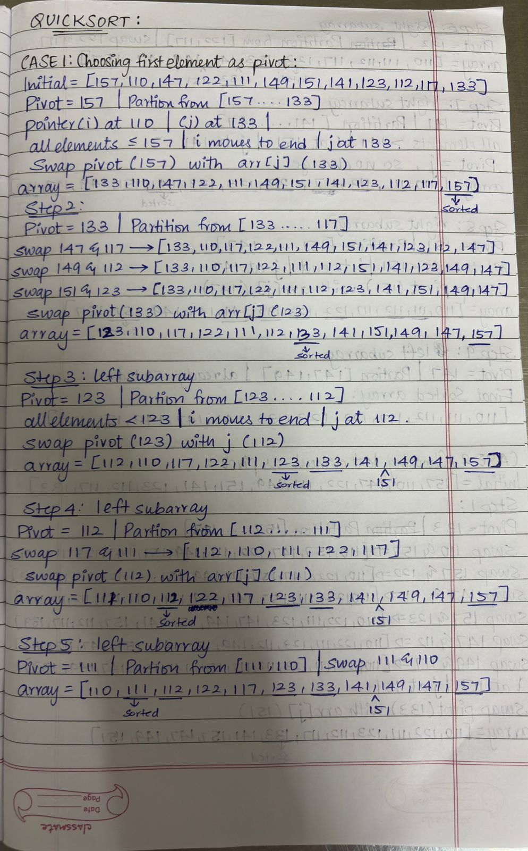

  - Case 2: Choosing last element as pivot:
Code:
#include <stdio.h>
int partitionLast(int a[],int low,int high){
int pivot=a[high];
int i=low-1;
for(int j=low;j<high;j++){
if(a[j]<=pivot){
i++;
int temp=a[i];
a[i]=a[j];
a[j]=temp;
}
}
int temp=a[i+1];
a[i+1]=a[high];
a[high]=temp;
return i+1;
}
void quickSortLast(int a[],int low,int high){
if (low<high){
int p=partitionLast(a,low,high);
quickSortLast(a,low,p-1);
quickSortLast(a,p+1,high);
}
}
int main(){
int a[]={157,110,147,122,111,149,151,141,123,112,117,133};
int n=12;
quickSortLast(a,0,n-1);
for(int i=0;i<n;i++)
printf("%d ",a[i]);
return 0;
}
Output:
Working:

  - Case 3: Choosing a random element as pivot:
Code:
#include <stdio.h>
#include <stdlib.h>
int partitionLast(int a[],int low,int high){
int pivot=a[high];
int i=low-1;
for(int j=low;j<high;j++){
if(a[j]<=pivot){
i++;
int temp=a[i];
a[i]=a[j];
a[j]=temp;
}
}
int temp=a[i+1];
a[i+1]=a[high];
a[high]=temp;
return i+1;
}
int partitionRandom(int a[],int low,int high){
int r=low+rand()%(high-low+1);
int temp=a[r];
a[r]=a[high];
a[high]=temp;
return partitionLast(a,low,high);
}
void quickSortRandom(int a[],int low,int high){
if (low<high){
int p=partitionRandom(a,low,high);
quickSortRandom(a,low,p-1);
quickSortRandom(a,p+1,high);
}
}
int main(){
int a[]={157,110,147,122,111,149,151,141,123,112,117,133};
int n=12;
quickSortRandom(a,0,n-1);
for(int i=0;i<n;i++)
printf("%d ",a[i]);
return 0;
}
Output:
Working:

